TXSELECT: A Web-Based Decision Support System for Regional Assessment of Potential E. coli Loads Using a Spatially Explicit Modeling Approach

Shubham Jain1, Raghavan Srinivasan2*, Thomas J. Helton3, and Raghupathy Karthikeyan4

1 Water Management and Hydrological Science, Texas A&M University, TX 77840, USA

2 Texas A&M AgriLife Research, Temple, TX 76502, USA

3 Texas State Soil and Water Conservation Board, Temple, TX 76504, USA

4 Department of Agricultural Sciences, Clemson University, SC 29634, USA

*Corresponding author. E-mail: [r-srinivasan@tamu.edu](mailto:r-srinivasan@tamu.edu);

Contributing authors: [shubhamjain0915@tamu.edu](mailto:shubhamjain0915@tamu.edu); [thelton@tsswcb.texas.gov](mailto:thelton@tsswcb.texas.gov); [rkarthikeyan@clemson.edu](mailto:rkarthikeyan@clemson.edu)

1. Abstract

Bacteria is a major cause of water body impairments throughout the United States, with more than 300 impaired water bodies for recreation within Texas in 2022. Bacterial source characterization and allocation are imperative to watershed planning and identifying best management practices. The Spatially Explicit Load Enrichment Calculation Tool (SELECT) has been extensively utilized in watershed protection plans to evaluate the potential bacteria loads and sources of bacteria in impaired watersheds. However, collecting data, compiling inputs, and spatially mapping sources can be arduous, time-intensive, expensive and an iterative process until the potential bacteria loads are appropriately allocated to sources based on stakeholder recommendations. We developed a web-based Decision Support System (DSS), TXSELECT, which provides a user-friendly interface to run the SELECT model on Texas watersheds. The DSS includes pre-determined watershed specific inputs that can be readily adjusted within the interface based on user preference and/or stakeholder recommendations, obviating the necessity for expensive GIS tools and data extraction. To illustrate the applications of TXSELECT, we implemented it to the entire coverage area to identify the potential hotspots and source contributions for *E. coli* at a regional scale. Results indicate that the median potential loads in impaired watersheds were significantly higher than in unimpaired watersheds. Also, urban watersheds had nearly four times more potential E. coli loads than rural watersheds due to a very high pet density. Overall, the large-scale application of SELECT has the potential to aid in prioritizing management measures in watersheds that are less frequently monitored but could have an elevated risk of impairment.

**Keywords:** nonpoint sources, fecal bacteria, *E. coli*, source characterization, decision support system, web-based application.

1. Introduction

Concentration of fecal indicator bacteria such as *E. coli* and *Enterococcus* are used to assess the overall water quality for pathogen contamination in rivers, lakes, and estuaries, which is the primary cause for water body impairments in Texas (TCEQ, 2022). In Texas, the 2004 303(d)-list contained 197 waterbodies categorized as impaired due to bacteria, which increased to 310 in 2006 and 342 in 2022 (Harmel et al., 2010; TCEQ, 2022). Bacteria impairments account for approximately 39% of more than seven thousand miles of assessed and impaired streams and rivers in Texas. In Oklahoma, bacteria impairments cause forty-six percent of five thousand miles of impaired streams and rivers (EPA, 2022).

Since the enactment of the Clean Water Act (CWA) in 1972, significant effort has been devoted to the establishment of Total Maximum Daily Loads (TMDLs) and the application of Best Management Practices (BMPs) to decrease the number of impaired water bodies in the United States (Schramm et al., 2022). Even though the CWA has regulated the point sources, the number of contaminated water bodies has not decreased. Nonpoint sources such as agricultural and livestock operations, failing On-Site Sewage Facilities (OSSFs), urban runoff, wildlife, and avian species can be broadly categorized as some of the major potential causes of bacteria impairments in a watershed (Teague et al., 2009). For impaired watersheds, identifying these sources and their degree of contribution becomes essential for implementing BMPs.

Bacterial Source Tracking (BST) is a popular approach to help identify and differentiate sources of fecal bacteria by DNA fingerprinting using collected soil and water samples from impaired sites (Casarez et al., 2007; DiGiovanni et al., 2013; Gregory et al., 2022). Process-based models such as Soil and Water Assessment Tool (SWAT) and Hydrological Simulation Program – FORTRAN (HSPF) can also be used to identify the sources and transport of bacteria (Benham et al., 2006; Douglas-Mankin et al., 2010; Moriasi et al., 2012). However, both BST and process-based models are rarely used in the development of TMDL reports and watershed Protection plans (WPPs) as BST is expensive, and process-based models are time-consuming, requiring extensive streamflow and water quality data for calibration and validation. On the other hand, the Spatially Explicit Load Enrichment Calculation Tool (SELECT), is a more straightforward GIS based approach that enables ranking bacteria loads from potential sources in a watershed by providing a snapshot of each source’s maximum daily bacteria load (Borel et al., 2012; Teague et al., 2009). Identifying causes or sources of pollution is one of nine key elements outlined by Environmental Protection Agency (EPA) for successful formulation of Watershed Protection Plans (WPPs), where SELECT has gained widespread popularity for characterizing and allocating bacteria loads, being applied in at least thirty-two EPA accepted WPPs in Texas. SELECT also finds its use in improving the bacteria source characterization within the Soil and Water Assessment Tool (SWAT) for modeling in-stream bacteria concentrations (Thilakarathne et al., 2018).

SELECT is used to identify potential *E. coli* loads from point and nonpoint sources using an automated script developed in ArcGIS (Riebschleager et al., 2012). Bacteria indicators such as livestock, wildlife, pets, wastewater treatment facilities, and failing on-site sewage facilities are typically identified as potential bacteria sources, and the sum of all major sources provides the daily loads. SELECT applies the approach based on recommendations by the EPA (USEPA, 2001) that specifies calculating the loads from each nonpoint source by multiplying the species excretion rate with the species population spatially at a sub-basin scale (Riebschleager et al., 2012; Teague et al., 2009). Therefore, SELECT estimates the maximum potential bacteria loads indicating the worst possible scenario from each source and allocates them spatially to a subbasin scale (Borel et al., 2012). This approach allows a more strategic allocation of BMPs in potential hotspots within a watershed.

Even though SELECT employs a straightforward methodology to estimate potential loads, it is still an arduous process in terms of data collection, analysis, and spatial mapping, necessitating repeated analyses due to stakeholder feedback and demanding proficiency with GIS tools for data processing and execution. Recent developments in web-based Decision Support Systems (DSS) for environmental modeling, such as the Hydrologic and Water Quality System (HAWQS) framework (Su et al., 2024; Yen et al., 2016), have reduced the computation time in preprocessing of datasets and modeling by many folds. In this study, we introduce a novel web-based DSS, TXSELECT, to estimate potential loads in Texas watersheds using the SELECT approach within a few minutes by eliminating the need for any preprocessed datasets and GIS tools. The key objectives for the development of TXSELECT DSS are:

1. Implement FAIR (Findable, Accessible, Interoperable, and Reusable) principles, as outlined by Wilkinson et al. (2019), in SELECT-based bacteria source characterization studies.
2. Reduce the computation time by several folds, through pre-defined datasets and watershed-specific input values.
3. Provide interactive map-based visualization of potential load distribution between subwatersheds and sources.
4. Allow for readily adjusting input values based on iterative stakeholder recommendations and enable a seamless workflow between multiple collaborators.
5. Eliminate the need for extensive knowledge of GIS tools or watershed modeling techniques.

Further sections in this paper present the TXSELECT framework, including the methods used to collect and prepare the pre-defined datasets. An implementation of TXSELECT is discussed to estimate potential loads over the entire coverage area using the default watershed-specific values. While users with a deeper knowledge of their relevant project watershed can tailor the inputs to better align with the stakeholder inputs, the default values present a coarse assessment of bacteria hotspots, sources, and their urban and rural contributions within the study region.

1. Study area and data

The geographical expanse of the study consists of three primary hydrological regions encompassing the Texas political boundary: the Texas Gulf region, the Arkansas-White-Red region, and the Rio Grande region. For these regions, the 2-digit (region), 4-digit (subregion) and 12-digit (subwatershed) Hydrologic Unit Code (HUC) boundaries, and corresponding channel routing information were gathered from the HAWQS version 2.0 (HAWQS, 2023) to maintain consistency between the two platforms. The spatial extent was then refined to select the hydrological area most relevant to the state of Texas. The subregions (HUC04) that do not intersect with the Texas boundary were removed from the study. Furthermore, considering the limited presence of water bodies and bacteria impairments in the Rio Grande region, only the subwatersheds (HUC12) intersecting with the Texas boundary were included. Also, due to limited data availability for subwatersheds partially located in Mexico, the HUC12 subwatersheds extending beyond the U.S. boundary were excluded. Figure 1 shows the resulting spatial extent and 7,633 HUC12 subwatersheds included in TXSELECT. These HUC12 subwatersheds represent the smallest spatial scale at which the pathogen loads are determined.

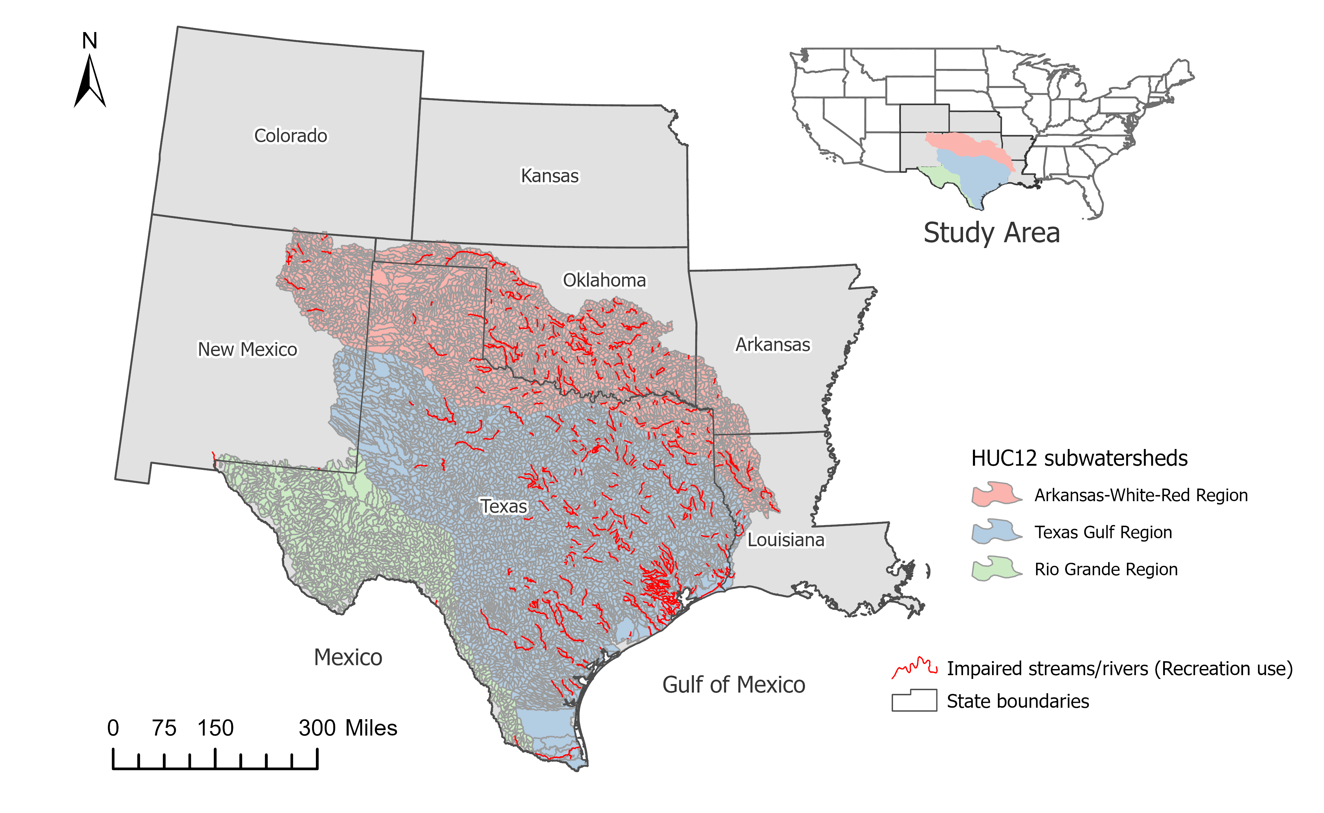

Figure 1. Location of 7,633 HUC12 subwatersheds included in the TXSELECT Decision Support System (DSS), overlain by the streams and rivers impaired for recreation use within the study area.

The datasets listed in Table 1 were used to create the pre-defined inputs in TXSELECT for the 7,633 HUC12 subwatersheds. The land cover percentages and soil classes were obtained from the 2021 National Land Cover Database (NLCD) and National Resources Conservation Service (NRCS) Soil Survey Geographic Database (SSURGO), respectively, at 30 meter resolutions and then aggregated to subwatershed scale (Dewitz, 2023; Soil Survey Staff et al.).

The population and housing unit counts at the subwatershed scale were calculated using the 2020 census block level estimates (USCB, 2020). The counts within each census block were assumed to be uniformly distributed over the census block area. Counts from blocks located entirely within the subwatershed boundary were summed without adjustments. For blocks partially located within the subwatershed, counts were multiplied by the proportion of the area of block within the subwatershed before being summed to obtain the total counts in each subwatershed.

The permitted discharges from wastewater outfalls were obtained from the US EPA Enforcement and Compliance History Online (ECHO) database (USEPA, 2020). The ECHOR package (Schramm, 2022) in R was used to access and retrieve the Discharge Monitoring Reports (DMRs) for facilities with an active municipal wastewater permit within the study watersheds. The most recent available full permitted discharge flows, and maximum permitted *E. coli or enterococcus* limit (Colony Forming Units (CFU)/100ml) for each facility were obtained and used to estimate the potential loads.

The OSSFs within each subwatershed were estimated using three different approaches: a) 911 address points, b) 2020 census housing units, and c) OSSFs reported in the 1990 census data. 911 address points and census housing units located outside of the certificated sewer service areas (Certificate of Convenience and Necessity (CCN) boundaries) were selected to obtain OSSF counts. Wherever the CCN boundaries were not available, urban area boundaries (USCB, 2020) were used to remove the addresses and housing units that are potentially covered by a municipal wastewater treatment plant. 911 addresses usually need to be manually verified to remove points that are not housing units, such as electric poles and barns. However, due to the large spatial extent of the dataset, this validation process was beyond the scope of this investigation, which may lead to overestimation of OSSF counts by 911 address points in certain subwatersheds. Also, the current extent of available 911 addresses data is limited to Texas, Arkansas, and New Mexico which remains to be updated in future versions (Figure S1). The 1990 census provided sewage disposal data for housing units, which is unavailable in the recent census reports. However, due to significant migration from rural to urban areas and the increase in public sewer connections across the state, these numbers may not adequately represent the current OSSF counts. As TXSELECT aggregates the bacteria loads at the HUC-12 subbasin scale, the exact OSSF location is not required. Therefore, the 2020 census housing units should be favored for assessing failing OSSFs, unless directed by stakeholder recommendations. However, all three alternatives are made available in the TXSELECT DSS.

Table 1. Description of data sources used in TXSELECT.

|  |  |  |  |
| --- | --- | --- | --- |
| **Type** | **Data** | **Description** | **Source** |
| GIS boundaries | Watershed | 2-digit, 4-digit, and 12-digit Hydrologic Unit Code (HUC) boundaries | (Simley & Carswell Jr, 2009) |
| Counties | County boundaries | (USCB, 2020) |
| Urban Area | 2020 Census Urbanized Area | (USCB, 2020) |
| CCN | Sewer Certificate of Convenience and Necessity (CCN) digital mapping data | (Public Utility Commission of Texas, 2024) |
| Livestock | Livestock counts | NASS 2017 Census of Agriculture County livestock counts | (NASS, 2017) |
| Wildlife | Deer density | TPWD Ecoregions average deer densities | (Lockwood, 2006) |
| Ecoregions | EPA Level IV Ecoregions | (Omernik & Griffith, 2014) |
| Demographic data | 1990 Census | Block level on-site Septic system counts reported in the 1990 Census | (USCB, 1990) |
| 2010 Census blocks | 2020 Census block polygons | (USCB, 2020) |
| 2020 Census demographics | 2020 Census Block Population and Housing Units | (USCB, 2010) |
| Address points | 911 address points | (Arctur, 2018; USDOT) |
| Watershed attributes | 2021 NLCD | 30-meter Land Cover raster from the 2021 National Land Cover Database | (Dewitz, 2023) |
| SSURGO | 30-meter SSURGO soil data | (Soil Survey Staff et al.) |
| PRISM | 30-Year Normal Precipitation: Annual | (Prism Climate Group, 2011) |
| Permitted discharges | WWTFs | Permitted discharges from the EPA Echo database | (USEPA, 2020) |

1. Methodology

This section provides the overall approach for the TXSELECT framework and methods for its implementation. The approach for estimating bacteria loads from various sources using spatially explicit methods is discussed in Section 3.1. Section 3.2. provides the operational framework for the TXSELECT, describing the processes involved in the framework, including initialization, customization, and output visualization. Finally, the methods for calculating and assessing the potential loads over the entire geographical extent are discussed in Section 3.3.

* 1. SELECT approach

The potential bacteria loads for HUC12 subwatersheds are estimated based on the EPA guidance (USEPA, 2001). The methodology for estimating the counts of each source and the default values used in TXSELECT are discussed below. The potential bacteria load for animals discussed below in each subwatershed is equal to the number of animals in the subwatershed multiplied by their corresponding fecal coliform production rate and the conversion factor from fecal coliform to a corresponding indicator bacterium.

* + 1. Pets

The population of domestic pets (dogs and cats) are estimated by multiplying a user-selected density per household in the study area by the total number of households within each subbasin. The number of households were estimated based on the census block-level data, as discussed in Section 2. A dog density of 0.614 dogs per household and a cat density of 0.457 cats per household is recommended as default densities based on the 2017 American Veterinarian Medical Association (AVMA) U.S. per ownership statistics (AVMA, 2017).

* + 1. Livestock

Livestock populations in TXSELECT include Cattle, Sheep, Goats and Equine. The number of heads for each livestock is estimated by multiplying the stocking rate (acres/head) by the total acreage of grazeable land cover in the subwatershed. Default grazeable NLCD land cover classes for livestock include Hay/Pasture, Grassland/Herbaceous, and Shrub/Scrub. The default stocking rate for each animal is calculated using the county-level livestock estimates (#heads) from National Agricultural Statistics Service (NASS) 2017 Census of Agriculture data for every county intersecting the subwatershed as shown below (NASS, 2017):

|  |  |
| --- | --- |
| $$SR \left(\frac{acres}{head}\right)= \sum_{i=1}^{N}{SR County_{i}}×Proportion of subwatershed grazing area in {County}_{i}$$ | (1) |

where, SR is the Stocking Rate of subwatershed, and N is the total number of counties intersecting the subwatershed. SR County is the grazeable land in county divided by #heads in county.

* + 1. Deer

The default suitable NLCD land cover classes for white-tailed deer include shrub/scrub, herbaceous, hay/pasture, cultivated crops, forests, and wetlands. Texas Parks and Wildlife Department (TPWD) (Lockwood (2006)) ecoregion-based estimates of deer densities are applied to each subwatershed. The dominant ecoregion in the subwatershed is obtained from the US EPA level III ecoregion mapping data (Omernik & Griffith, 2014). These default deer densities are applied to the suitable NLCD land cover acreage to obtain counts of deer in each subwatershed.

* + 1. Feral Hogs

For feral hogs, default suitable NLCD land cover classes for white-tailed deer include shrub/scrub, herbaceous, hay/pasture, cultivated crops, forests, and wetlands. A default density of 33.3 acres per hog is a common practice in most watershed studies in Texas. However, this may lead to overestimation of feral hogs in regions unsuitable for feral hog habitat. Therefore, a default density of 76 acres per hog is applied to regions with < 20 inches of average annual precipitation (western portion of the study area), while 33.3 acres per hog is applied to subwatersheds with ≥ 20 inches of average annual precipitation based on PRISM 30-year (1991-2020) precipitation normals data (Prism Climate Group, 2011; Timmons et al., 2012).

* + 1. On-site sewage facilities (OSSFs)

The number of OSSFs are determined based on the estimated households in the subwatershed that do not have access to any sewer utility service. Three approaches are available for the user to select the number of OSSFs, as discussed in Section 2. The estimated failure rates for OSSFs in each subbasin are calculated using the dominant Septic Drainfield Limitation Class obtained from the Soil Surface Geographic SSURGO database (Soil Survey Staff et al.). Default recommended failure rates are applied based on the classes: very limited (15%), somewhat limited (10%), not limited (5%), and not rated (8%). These failure rates are used to calculate the total number of failing OSSFs in the subbasins. The average number of persons per household with a failing OSSF is estimated by dividing the total subbasin population by the total housing units. Finally, the OSSF load is calculated using the equation below.

|  |  |
| --- | --- |
| $$Load =\#Failing OSSFs ×PR ×CF ×\frac{70 gal}{person. day} ×\frac{\#Person}{Household} ×3758.2\frac{mL}{gal}$$ | (2) |

where, PR is the production rate of fecal coliform for OSSFs (Table 2), and CF is the conversion factor from fecal coliform to a corresponding indicator bacterium.

* + 1. Wastewater Treatment Facilities (WWTFs)

The active permitted wastewater treatment facilities in each subwatershed were obtained from the Environmental Protection Agency (EPA) Enforcement and Compliance History Online (ECHO) database (USEPA, 2020). The most recent full permitted discharge and allowable daily average pathogen limit (CFU/100ml) are obtained and used to estimate daily pathogen loads using the equation below.

|  |  |
| --- | --- |
|  | (3) |

* + 1. Bacteria production rates

Daily pathogen loads for subwatersheds are calculated by multiplying the counts of each source to their respective production rates. The US EPA guidelines document on Protocols for Developing Pathogen TMDLs summarizes published production rates for several sources (USEPA, 2001). However, the production rates vary between studies by several orders of magnitude (Wagner & Moench, 2009). Wagner and Moench (2009) compared the daily fecal coliform densities per gram of feces and daily fecal production from livestock and wildlife sources and recommended the fecal coliform production rates per Animal Unit (A.U.). The fecal coliform production rates per A.U. from Wagner and Moench (2009) multiplied by the respective animal heads per A.U. for Livestock (Cattle, Sheep, Goats, and Horses) and Wildlife (Feral Hogs and Deer) were used as default values in the TXSELECT (Table 2). For OSSFs and pets, the maximum fecal coliform production rates listed in the EPA guidance document were used (USEPA, 2001). Further, a conversion factor is applied to calculate *E. coli* and *Enterococcus* loads from fecal coliform. Default values of the conversion factor (0.63 for *E. coli* and 0.175 for *Enterococcus*) are recommended based on the 2010 Texas Surface Water Quality regulatory standards in recreational waters (Borel et al., 2015; TCEQ, 2010).

Table 2. Pathogen production rates to estimate bacteria loads in Texas watersheds. These production rates are applied as default rates in TXSELECT.

|  |  |  |
| --- | --- | --- |
| **Source** | **Fecal coliform production rate** | **Reference** |
| Cattle | 8.55 × 109 cfu/head/day | (Wagner & Moench, 2009) |
| Sheep | 5.8 × 1010 cfu/head/day |
| Goats | 4.32 × 109 cfu/head/day |
| Horses | 3.64 × 108 cfu/head/day |
| Deer | 1.68 × 109 cfu/head/day |
| Feral Hogs | 1.51 × 108 cfu/head/day |
| Dogs and Cats | 5 × 109 cfu/head/day | (USEPA, 2001) |
| OSSFs | 10 × 106 /100ml |

* 1. DSS Framework

The approach for evaluating potential bacteria loads within the TXSELECT DSS can be broadly categorized into three steps: Initialization, Customization, and Output Demonstration, succinctly elaborated upon in this section. Figure 2 shows a broad architecture and procedural aspects underlying TXSELECT. Once the user has created a free account on the website, the tool facilitates storage and management of multiple concurrent watershed projects linked to the user's account, enabling convenient access and seamless customization.

Figure 2. Conceptual design of the TXSELECT Decision Support System (DSS) guided by FAIR (Findable, Accessible, Interoperable, and Reusable) principles.

* + 1. Initialization

Once the user account is set up, the initialization process involves delineating a new project watershed. A project is initiated by selecting the most downstream HUC12 subbasin for the watershed of interest. The HUC12 subbasin can be selected by entering the exact 12-digit number of the HUC12 watershed or clicking on a location within the HUC12 watershed in an interactive leaflet-based map displayed on the interface. All the HUC12 watersheds contributing to the downstream HUC-12 unit are automatically selected as contributing subbasins. By selecting starting subbasins, the user also has an advanced option to limit the entire contributing drainage area to a few downstream subbasins. Once the subbasins are selected and the project is initiated, the user can visualize the watershed characteristics, including drainage area, land cover, and the fraction of counties, and begin adjusting inputs for estimating potential loads.

* + 1. Customization

Even though the tool provides pre-determined, region-specific default values for estimating source-specific loads, the numbers can always be adjusted based on stakeholder inputs who have more profound knowledge about the watershed, such as livestock stocking rate and wildlife densities. The customization process of the TXSELECT tool involves adjusting the default values in the DSS to more appropriate values based on user or stakeholder recommendations. These include pet densities, livestock stocking rates, wildlife densities, failing OSSFs counts, and unaccounted WWTFs. The default fecal coliform production rates and conversion factor can also be adjusted based on user requirements or if estimating *Enterococcus* loads instead.

Specifically, for each livestock and wildlife animal, the user could select suitable land covers and apply the densities based on county-level numbers or specify tailored stocking rates for each subbasin. For pets, default dog and cat densities can be adjusted. Three alternatives are available for OSSF counts: 2010 Census Housing Units, 911 addresses, and 1990 census records. Failure rates and wastewater generated in gallons per person per day can also be adjusted for estimating OSSF loads. For WWTFs, the DSS also provides options to add or remove any facility or adjust existing facilities' daily discharge and bacteria limits.

* + 1. Output Demonstration

After the inputs have been tailored to represent the appropriate counts of sources in the watershed, users can calculate and visualize the source-specific potential loads and total loads for each subbasin within a few seconds. The generated outputs include interactive maps identifying the dominant sources within each subbasin and their contribution. Alternatively, the potential loads in Billion CFU/day can be obtained in a tabular format. Moreover, the DSS offers functionalities for generating comprehensive project reports, archiving, and sharing completed projects to ensure reproducibility.

* 1. Implementation

We demonstrate the TXSELECT approach to calculate potential *E. coli* loads from the pre-determined input datasets and evaluate a statewide distribution of source-specific loads in all 8,313 HUC-12 subbasins within the study area. It is important to note that while these default values are the best representation of the HUC12 subwatersheds and have been consistently used in several past studies, these numbers are often adjusted in watershed-specific studies based on stakeholder and watershed coordinators' recommendations which is the whole purpose of TXSELECT.

* + 1. Potential E. coli load estimation

The default values in TXSELECT as discussed in previous sections were used over the entire study area as inputs to estimate the potential *E. coli* loads. These include a pet density of 0.614 for dogs and 0.457 for cats per household. The livestock stocking rates are estimated using county-level livestock counts and applied to suitable land cover acreages (Shrub/Scrub, Grassland/Herbaceous, and Pasture). Although, in counties with multiple Concentrated Animal Feeding Operations (CAFOs), predominantly in the Texas panhandle, the stocking rates for livestock (especially Cattle), can be misrepresented due to large number of livestock within these CAFOs. As CAFOs are regulated by US EPA NPDES permits to limit pollutant discharge, the potential bacteria load from livestock within CAFOs should not be directly estimated. However, data on the actual counts of livestock within these CAFOs is not publicly available, which makes it unfeasible to directly remove the livestock counts within CAFOs from the county-level estimates. To address this issue to some extent, we established a minimum threshold stocking rate of 3 acres of suitable land cover per Cattle. Counties with large counts of Cattle due to the presence of CAFOs, resulting in very low stocking rates were adjusted to the threshold to remove a large percentage of Cattle in those CAFOs. As the population of other livestock is not significantly present in CAFOs, a similar approach was not feasible for other animals.

Default densities for feral hogs and deer were applied to their suitable NLCD land cover classes (shrub/scrub, herbaceous, hay/pasture, cultivated crops, forests, and wetlands). The OSSF counts were estimated using the 2020 housing units outside of sewer CCN or urban area boundaries. For WWTFs, the allowable daily average bacteria and discharge limits were used.

* + 1. Watershed classification

To better evaluate the distribution of potential sources of bacteria and categorize the differences in potential loads between watersheds, we classified the 7,633 subwatersheds in the study area into six major categories based on two separate classifications. First, we categorized the subwatersheds into urban or rural classes based on land cover and housing density. HUC12 subwatershed with more than 20 percent of developed NLCD land cover or a housing density of more than 200 housing units per km2 were classified as urban subwatersheds, and the rest were classified as rural. A total of 380 subwatersheds were categorized as urban watersheds.

Further, we used the US EPA ATTAINS (USEPA, 2023) dataset to identify the recreation use attained for each of the subwatershed. Each urban or rural subbasin was further classified as Not Supporting, Fully Supporting, and Not Assessed based on the recreation use classification of the assessment unit within the HUC12 subwatershed. Subwatersheds with no assessment units were also classified as Not Assessed. This resulted in 1,354 subwatersheds categorized as Not Supporting, 1,796 classified as Fully Supporting, and 4,483 designated as Not Assessed.

* + 1. Evaluation metrics

To evaluate if the total potential loads significantly differed between the watershed classifications, we used a Mann-Whitney U test at a significance level of p < 0.05. In addition, box plots were used to examine the differences between watershed categories based on the median, minimum, maximum, and 25th and 75th percentile values. Further, the source-specific potential loads and the cumulative subbasin loads were also individually divided into five classes: Very High, High, Moderate, Low, and Negligible, using the Jenks optimization method to spatially cluster subwatersheds and identify hotspots for each potential source within the geographical extent of the study.

1. Results and Discussion
   1. Spatial distribution of E. coli sources

The source-specific total potential *E. coli* loads used to calculate the contribution of each source to the 8,313 HUC-12 subbasins within the three major hydrological regions of Texas are summarized in Table 3. A total count of more than 16 million cattle and 12 million domestic pets (dogs and cats) were the two primary sources of potential loads in most watersheds. Although, cattle loads were more dominant in rural watersheds with larger populations in the Arkansas-white-red region. Pet loads were dominant in the Texas Gulf region, including most urban areas. OSSF loads were also majorly concentrated surrounding the urban areas, with more than 320,000 OSSFs failing out of 2.2 million estimated.

The lowest average potential loads were found to be from the WWTFs. Due to the limited number of WWTFs spread vastly among the study area, most subbasins did not include a WWTF. Also, since the CWA 1972, the WWTF has been heavily regulated, limiting the number of excess pollutants or breaking the limits. Feral hogs and Equine densities were also very limited. Of the three major hydrological regions, the Rio-Grande region had the lowest total *E. coli* loads due to limited human activities. The Texas-Gulf region had the highest potential *E. coli* loads and impaired subbasins.

Table 3. Summary statistics of estimated total animal counts and daily potential *E. coli* loads.

|  |  |  |  |  |  |  |  |
| --- | --- | --- | --- | --- | --- | --- | --- |
| **Potential *E. coli* sources** | **Total count (Million)** | **Potential *E. coli* load (106 MPN/hectare-day)** | | | | | |
| **Arkansas-White-Red Region** | | **Texas-Gulf Region** | | **Rio-Grande Region** | |
| **Maximum** | **Mean** | **Maximum** | **Mean** | **Maximum** | **Mean** |
| Cattle | 14.31 | 4,439.77 | 1067.95 | 4,242.00 | 719.1 | 889.69 | 103.08 |
| Goats & Sheep | 1.65 | 1073.2 | 38.78 | 6,532.29 | 181.63 | 4,437.43 | 78.215 |
| Equine | 0.42 | 7.64 | 0.65 | 14.65 | 0.96 | 1.71 | 0.16 |
| Deer | 8.71 | 152.23 | 97 | 384.41 | 75.8 | 384.49 | 96.29 |
| Hogs | 5.09 | 7.84 | 6.66 | 7.44 | 6.68 | 7.06 | 3.08 |
| Failing OSSFs | 0.15 | 1977 | 14.435 | 5,655.55 | 25.96 | 1190.04 | 0 |
| Pets | 13.5 | 21,185.12 | 26.3 | 49,972.64 | 70.29 | 20,464.54 | 0.55 |
| WWTF | - | 92.02 | 0 | 1736.98 | 0 | 12.64 | 0 |
| Total | - | 21,189.78 | 1440.09 | 49,999.75 | 1792.36 | 20,545.88 | 459.53 |

Figure 4 illustrates the spatial distribution of E*. coli* loads from individual sources and the total potential load within HUC-12 watersheds. The potential load values are categorized into five classes to identify the potential hotspots for each source. The highest cattle population is concentrated in the Texas panhandle in the northern high plains. Deaf smith county has the highest cattle population, with 592,087 heads based on the 2017 NASS census. The HUC-12 subbasins within this region with the highest percentages of grazable lands were allocated the largest cattle loads in the SELECT analysis. Contrastingly, potential loads from Goats and Sheep were highest in the Edwards plateau region, with the highest populations in the Sutton and Crockett counties. Equine populations were most highly concentrated in the Parker and Denton counties surrounding the Dallas Metropolitan area.

The Rio-Grande region had the highest potential loads from deer, notably in the Chihuahuan Desert, with 94 deer per 1000 acres. Conversely, due to the prevailing arid conditions with an average annual rainfall of less than 20 inches across much of the Rio-Grande region, the potential loads from feral hogs were negligible in most of the watersheds in this region. Pet loads were directly correlated to the housing density making the urban classified watersheds with the highest potential pet loads.

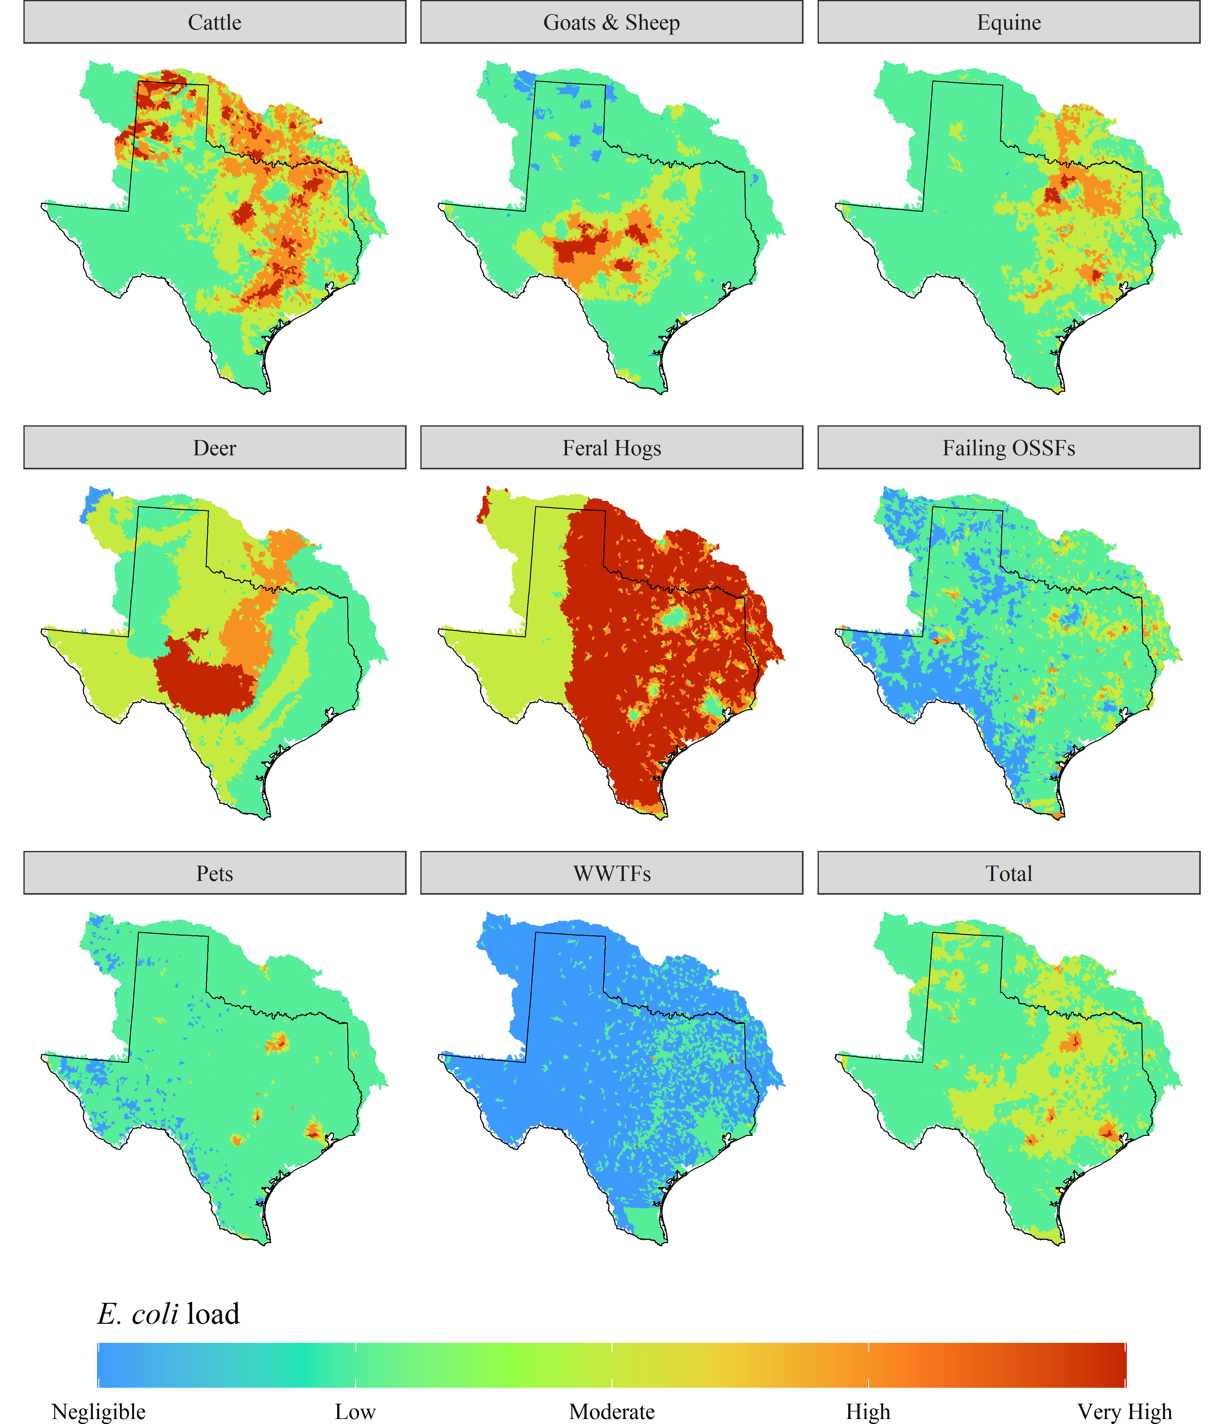

Figure 3. Map showing hotspots of average daily potential *E. coli* loads from each individual source and the total load from all sources. The potential loads for each source are split into five classes: Very High, High. Moderate, Low, and Negligible based on natural Jenks optimization.

* 1. Potential causes for impairments

A comparison of median potential loads from various sources within the impairment classes in rural and urban category watersheds is illustrated in Table 4. Results indicate that the median total potential loads in watersheds impaired for recreation use were higher than unimpaired and unassessed watersheds for rural and urban categories. Most of the difference between impaired and unimpaired watersheds in rural watersheds can be attributed to potential cattle loads (Figure 5). The median total potential loads in urban watersheds were nearly four times higher than the rural watersheds causing a higher chance of impairment. In urban watersheds, even though median livestock loads were higher in unimpaired watersheds, pet loads were responsible for the increase in potential bacteria loads, making many of these watersheds impaired.

Table 4. Median *E. coli* loads by source for subwatersheds contributing to Fully Supporting, Not Supporting, or Not Assessed waterbodies for contact recreation in urban and rural categories.

|  |  |  |  |  |  |  |
| --- | --- | --- | --- | --- | --- | --- |
|  | **Median *E. coli* Load (Million MPN/acre-day)** | | | | | |
| **Source** | **Rural** | | | **Urban** | | |
| **Not Supporting** | **Fully Supporting** | **Not Assessed** | **Not Supporting** | **Fully Supporting** | **Not Assessed** |
| Cattle | 1151.2 | 861.57 | 558.12 | 332.87 | 417.28 | 584.37 |
| Goats & Sheep | 89.56 | 94.23 | 84.295 | 106.33 | 212.27 | 182.3 |
| Equine | 1.24 | 0.91 | 0.41 | 1.375 | 1.67 | 1.79 |
| Deer | 91.865 | 97.24 | 96.56 | 26.31 | 36.42 | 39.37 |
| Hogs | 6.65 | 6.66 | 6.66 | 3.345 | 3.9 | 4.14 |
| Failing OSSFs | 47.165 | 32.12 | 4.97 | 50.78 | 110.6 | 133.72 |
| Pets | 86.95 | 62.7 | 8.855 | 6631.94 | 3616.48 | 3704.89 |
| WWTF | 0 | 0 | 0 | 1.035 | 0.08 | 0 |
| Total | 1773.56 | 1593.52 | 1147.44 | 7756.34 | 5327.67 | 5844.14 |
| N | 1172 | 1711 | 4370 | 182 | 85 | 113 |

Figure 4 illustrates the total potential *E. coli* load distribution between urban and rural watersheds. The Man-Whitney U-test showed that the potential total loads in Impaired watersheds were significantly higher than the unimpaired and not assessed watersheds in both urban and rural watersheds under a 0.05 significance level. Even though the potential loads may be higher in one watershed, the actual loading to the stream can depend on several factors, such as the location of the source with respect to the stream, bacteria die-off, and several other factors. These factors can substantially affect the E. coli levels within the water body, causing it to be classified as unimpaired even though the potential loads are substantially high.

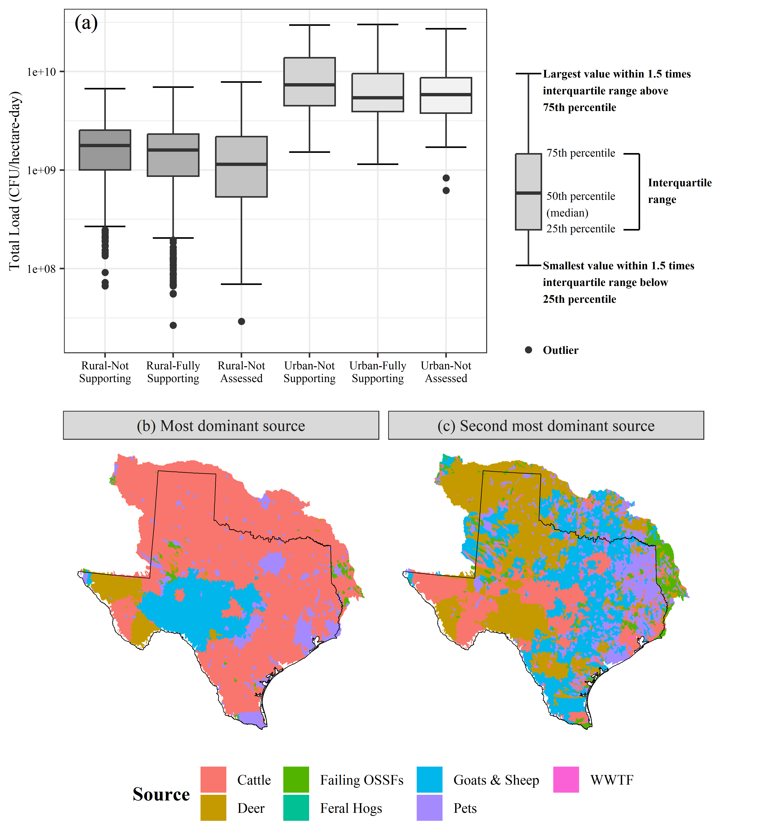

Figure 4. (a) Plot showing the distribution of total loads in Rural and Urban watersheds between Not Supporting, Fully Supporting, and Not Assessed watersheds. (b) Map showing the most dominant source in each HUC12 subwatershed. (c) Map showing the second most dominant source in each HUC12 subwatershed.

* 1. Limitations

The livestock stocking rates are based on county level estimates and applied to the same NLCD land cover classes throughout the study area. However, the actual stocking rates can vary between land cover classes, subwatersheds, seasons, or years which can alter the results of the SELECT analysis. Similarly, densities for deer and feral hogs can vary within ecoregions and precipitation zones, respectively as well. A manual validation of OSSF numbers can also alter the potential OSSF loads within but was not feasible for this analysis. However, the TXSELECT tool facilitates watershed planners to make these adjustments based on local stakeholder recommendations when applying the SELECT approach in watershed assessment studies.

Wildlife population can have a large contribution towards bacteria loadings due to their proximity to riparian zones. The current TXSELECT approach is only limited to deer and feral hog species, but several other wild animals and birds can significantly contribute to the bacteria loadings in the watershed. However, it is difficult to adequately assess their source contributions and loadings due to the limited knowledge regarding their spatial distribution of population estimates and fecal production rates.

* 1. Ongoing work and future advancements

Based on the existing architecture of the TXSELECT framework, which allows for an automated and user-friendly setup for estimating potential loads, our initial objective is to expand the geographical coverage of this tool to the conterminous United States at the HUC12 spatial resolution. A significant challenge in this regard is the processing of pre-loaded datasets. While most datasets, such as land cover, agricultural statistics, and soil characteristics, are readily available at the continental scale, others, including wildlife densities, 911 addresses, and OSSF failure rates, must be collected and validated. When expanding it to a national scale, it would also be crucial to incorporate other potential sources of bacteria, such as avian populations.

The tool's enduring efficacy and acceptance depend on its continuous upkeep, regularly updated datasets, and proper validation. Ensuring regular updates and validation of dynamic datasets such as WWTFs, land cover, and census data are essential. Further, including a scenario generation module in the existing framework could allow users to visualize the changes in potential bacteria loads based on projected changes in population or management strategies recommended to reduce bacteria loads. We also aim to integrate the SELECT approach with HAWQS to provide inputs for bacteria sources and aid in improving the efficiency of bacteria modeling within the HAWQS platform.

1. Conclusions

This study introduced TXSELECT, the first and only existing web-based DSS for estimating potential bacteria loads in watersheds using the spatially explicit approach. The DSS is equipped with pre-loaded datasets and has GIS capabilities to visualize the potential sources, their contributions and identify hotspots in large watersheds at a HUC12 level spatial resolution while eliminating the need for extensive resources otherwise required to conduct the analysis. The quick setup, pre-loaded values, and tools for efficient management of projects allow for enhanced reproducibility and a fluent collaboration between watershed coordinators and stakeholders while developing a watershed plan.

In addition, we also presented an analysis for potential daily *E. coli* loads in the entire study area to provide a large-scale statewide assessment of the distribution of potential *E. coli* sources and major causes for impairments in Texas watersheds. We found pets to be a major source of urban watershed impairments, whereas cattle loads were the highest in rural watersheds. Potential total loads were significantly higher in impaired rural watersheds than in unimpaired watersheds. Urban watersheds also had nearly four times higher median potential loads than rural impaired watersheds, which can be attributed to the high pet density in urban watersheds. Overall, the statewide assessment of potential *E. coli* loads provides a baseline to direct future efforts in potential hotspots for bacteria at a state level and allows us to be more proactive in developing management measures for water bodies that can potentially become impaired.

1. Acknowledgements

This project is supported by the Texas State Soil & Water Conservation Board and Texas A&M AgriLife Research. The views expressed in this study are those of the authors and do not necessarily reflect the views or policies of the Texas State Soil & Water Conservation Board and Texas A&M AgriLife Research.

1. Open Research

The TXSELECT tool is available for use at this site: [TXSELECT.tamu.edu](http://www.tx.select.tamu.edu). All code used in this project is available at this site: [github.com/shubhamjain15/TX-SELECT](https://github.com/shubhamjain15/TX-SELECT). All input GIS and data files required to reproduce the analysis in this project are made available at this site: <need to add Texas data repository link>.

1. Author contribution

Shubham Jain: Conceptualization, analysis, Methodology, Writing – original draft, review & editing. Raghavan Srinivasan: Conceptualization, Methodology, Writing – review & editing. Thomas J. Helton: Writing – review & editing. R. Karthikeyan: Writing – review & editing.

1. References

Arctur, D. (2018). *Texas Addresses Basemap Collection, HydroShare*. <https://doi.org/10.4211/hs.9d510596780b4d6a871078adc7be79c4>

AVMA. (2017). *American Veterinary Medical Association. U.S. pet ownership statistics*. Retrieved 01/20/2020 from <https://www.avma.org/resources-tools/reports-statistics/us-pet-ownership-statistics>

Benham, B. L., Baffaut, C., Zeckoski, R. W., Mankin, K. R., Pachepsky, Y. A., Sadeghi, A. A., Brannan, K. M., Soupir, M. L., & Habersack, M. J. (2006). Modeling bacteria fate and transport in watersheds to support TMDLs [Review]. *Transactions of the Asabe*, *49*(4), 987-1002. <Go to ISI>://WOS:000240580400014

Borel, K., Karthikeyan, R., Berthold, T. A., & Wagner, K. (2015). Estimating E. coli and Enterococcus loads in a coastal Texas watershed. *Texas Water Journal*, *6*(1), 33-44.

Borel, K. E., Karthikeyan, R., Smith, P. K., Gregory, L. F., & Srinivasan, R. (2012). Estimating daily potential E. coli Loads in pural Texas watersheds using Spatially Explicit Load Enrichment Calculation Tool (SELECT). *Texas Water Journal*, *3*(1), 42-58. <https://doi.org/10.21423/twj.v3i1.6164>

Casarez, E. A., Pillai, S. D., Mott, J. B., Vargas, M., Dean, K. E., & Di Giovanni, G. D. (2007). Direct comparison of four bacterial source tracking methods and use of composite data sets [Article]. *Journal of Applied Microbiology*, *103*(2), 350-364. <https://doi.org/10.1111/j.1365-2672.2006.03246.x>

Dewitz, J. (2023). *National Land Cover Database (NLCD) 2021 Products: U.S. Geological Survey data release*. <https://doi.org/10.5066/P9JZ7AO3>.

DiGiovanni, G., Casarez, E., Gentry, T., Martin, E., Gregory, L., & Wagner, K. (2013). *Support analytical infrastructure and further development of a statewide bacterial source tracking library*.

Douglas-Mankin, K. R., Srinivasan, R., & Arnold, J. G. (2010). SOIL AND WATER ASSESSMENT TOOL (SWAT) MODEL: CURRENT DEVELOPMENTS AND APPLICATIONS [Article]. *Transactions of the Asabe*, *53*(5), 1423-1431. <Go to ISI>://WOS:000284818500006

EPA. (2022). *How's My Waterway*. Retrieved 05/07/2023 from

Gregory, L., Hux, B., Gentry, T. J., Gitter, A., Monserrat, C., & Mena, K. D. (2022). Texas Bacterial Source Tracking Program.

Harmel, R. D., Karthikeyan, R., Gentry, T., & Srinivasan, R. (2010). EFFECTS OF AGRICULTURAL MANAGEMENT, LAND USE, AND WATERSHED SCALE ON E-COLI CONCENTRATIONS IN RUNOFF AND STREAMFLOW [Article]. *Transactions of the Asabe*, *53*(6), 1833-1841. <Go to ISI>://WOS:000285904900009

HAWQS. (2023). *HAWQS System 2.0 and Data to model the lower 48 conterminous U.S using the SWAT model* Version V2) [GIS, Temporal and Spatial data, Model inputs and outputs]. Texas Data Repository. <https://doi.org/doi:10.18738/T8/GDOPBA>

Lockwood, M. (2006). White-tailed deer population trends. *Texas Parks and Wildlife Department, Austin*.

Moriasi, D. N., Wilson, B. N., Douglas-Mankin, K. R., Arnold, J. G., & Gowda, P. H. (2012). HYDROLOGIC AND WATER QUALITY MODELS: USE, CALIBRATION, AND VALIDATION [Article]. *Transactions of the Asabe*, *55*(4), 1241-1247. <Go to ISI>://WOS:000309089900011

NASS. (2017). 2017 Census of Agriculture. In.

Omernik, J. M., & Griffith, G. E. (2014). Ecoregions of the Conterminous United States: Evolution of a Hierarchical Spatial Framework [Article]. *Environmental Management*, *54*(6), 1249-1266. <https://doi.org/10.1007/s00267-014-0364-1>

Prism Climate Group. (2011). PRISM climate data. *Oregon State University*.

Public Utility Commission of Texas. (2024). *CCN Mapping Information. PUC CCN Water and Sewer GIS Shapefiles*. <https://www.puc.texas.gov/industry/water/utilities/gis.aspx>

Riebschleager, K. J., Karthikeyan, R., Srinivasan, R., & McKee, K. (2012). Estimating Potential E. coli Sources in a Watershed Using Spatially Explicit Modeling Techniques [Article]. *Journal of the American Water Resources Association*, *48*(4), 745-761. <https://doi.org/10.1111/j.1752-1688.2012.00649.x>

Schramm, M. (2022). *{echor}: Access EPA 'ECHO' Data*. Retrieved 20/02/2020 from <https://CRAN.R-project.org/package=echor>

Schramm, M., Gitter, A., & Gregory, L. (2022). Total Maximum Daily Loads and Escherichia coli Trends in Texas Freshwater Streams [Article]. *Journal of Contemporary Water Research & Education*, *176*(1), 36-49. <https://doi.org/10.1111/j.1936-704X.2022.3374.x>

Simley, J. D., & Carswell Jr, W. J. (2009). The national map—hydrography. *US Geological Survey Fact Sheet*, *3054*(4).

Soil Survey Staff, Natural Resources Conservation Service, & United States Department of Agriculture. *Web Soil Survey*. Retrieved 03/10/2020 from <https://websoilsurvey.nrcs.usda.gov/>

Su, Q., Srinivasan, R., & Karthikeyan, R. (2024). SC.HAWQS: A User-Friendly Web-Based Decision Support System for Regional Water Resources Management Under a Changing Climate. *Water Resources Management*. <https://doi.org/10.1007/s11269-023-03719-2>

TCEQ. (2010). *2010 Texas Surface Water Quality Standards*. Retrieved 01/15/2020 from <https://www.tceq.texas.gov/waterquality/standards/2010standards.html>

TCEQ. (2022). *2022 Texas Integrated Report of Surface Water Quality for Clean Water Act Sections 305(b) and 303(d)*. <https://www.tceq.texas.gov/waterquality/assessment/22twqi/22txir>

Teague, A., Karthikeyan, R., Babbar-Sebens, M., Srinivasan, R., & Persyn, R. A. (2009). SPATIALLY EXPLICIT LOAD ENRICHMENT CALCULATION TOOL TO IDENTIFY POTENTIAL E. COLI SOURCES IN WATERSHEDS [Article]. *Transactions of the Asabe*, *52*(4), 1109-1120. <Go to ISI>://WOS:000269783100007

Thilakarathne, M., Sridhar, V., & Karthikeyan, R. (2018). Spatially explicit pollutant load-integrated in-stream <i>E-coli </i>concentration modeling in a mixed land-use catchment [Article]. *Water Research*, *144*, 87-103. <https://doi.org/10.1016/j.watres.2018.07.021>

Timmons, J. B., Higginbotham, B., Lopez, R., Cathey, J. C., Mellish, J., Griffin, J., Sumrall, A., & Skow, K. (2012). Feral hog population growth, density and harvest in Texas. *Texas A&M AgriLife Extension Service Report.(Texas A&M University: College Station, TX.)*.

USCB. (1990). *1990 Census Data*.

USCB. (2010). *2010 Census*. Retrieved 03/20/2020 from <http://www.census.gov/2010census/data/>

USCB. (2020). United States Census Bureau. 2020 TIGER/Line Shapefiles (machine‐readable data files).

USDOT. (2020). *National Address Database*. Retrieved 02/20/2020 from <https://www.transportation.gov/gis/national-address-database>

USEPA. (2001). *Protocol for Developing Pathogen TMDLs*.

USEPA. (2020). *Enforcement and Compliance History Online*. Retrieved 02/20/2020 from <https://echo.epa.gov/>

USEPA. (2023). *The Assessment, Total Maximum Daily Load (TMDL) Tracking and Implementation System (ATTAINS)*. <www.epa.gov/waterdata/attains>

Wagner, K., & Moench, E. (2009). *Education Program for Improved Water Quality in Copano Bay Task Two Report*.

Wilkinson, M. D., Dumontier, M., Aalbersberg, I. J., Appleton, G., Axton, M., Baak, A., Blomberg, N., Boiten, J.-W., Santos, L. B. d. S., Bourne, P. E., Bouwman, J., Brookes, A. J., Clark, T., Crosas, M., Dillo, I., Dumon, O., Edmunds, S., Evelo, C. T., Finkers, R., . . . Mons, B. (2019). The FAIR Guiding Principles for scientific data management and stewardship (vol 15, 160018, 2016) [Correction]. *Scientific Data*, *6*, Article 6. <https://doi.org/10.1038/s41597-019-0009-6>

Yen, H., Daggupati, P., White, M. J., Srinivasan, R., Gossel, A., Wells, D., & Arnold, J. G. (2016). Application of Large-Scale, Multi-Resolution Watershed Modeling Framework Using the Hydrologic and Water Quality System (HAWQS) [Article]. *Water*, *8*(4), Article 164. <https://doi.org/10.3390/w8040164>